❒

Smart helmet using internet of things : (IOT)

# Article Info ABSTRACT

## Article history:

Received May 26, 2023

Revised June 29, 2023

## Keywords:

Android ATtiny85 Bluetooth sensor Firebase

Internet of thing Piezoelectric sensor

Google Assistant

GPS

This project aims to design and develop a Smart Helmet using IoT technology for the safety of motorcycle riders. The main feature of the helmet is to detect accidents and send an alert to the emergency contacts pre-selected by the rider. The helmet will be equipped with Google Assistant, a location tracker, a built-in speaker, and a microphone to provide additional features such as navigation, voice control, and communication. The helmet will also have camera holders to allow riders to capture their rides. In case of an emergency, the helmet will send an SOS signal using Morse code for the rider's safety in worst-case scenarios. The accident detection feature will be connected to a mobile app that will send alerts to emergency contacts. Furthermore, the emergency alert system will send alerts to the nearest hospitals and police stations using national emergency numbers [like](https://creativecommons.org/licenses/by-sa/4.0/) 100 and

101, along with the*.* last coordinate location of the helmet. [The Smart](https://creativecommons.org/licenses/by-sa/4.0/) Helmet will help ensure the safety of the rider and provide peace of mind to their loved ones.

## Corresponding Author:

Mayukh sahana Nishanta lenka

# INTRODUCTION:

In India around 4-5 people die due to road accident, Many reasons are behind this and these

conditions are responsible for death in our country and some are due to cattle coming in front of them, due to bad road conditions driver's fault, and many more. Mainly the injury happens to our skull, knee, and elbow. The most dangerous injury which happens after head trauma, may lead to concussion or brain hemorrhage. In all cases, Brain is the main part and due to accident severe injury happens in the brain only looking at this scenario we came up with our project named 'Smart Helmet ' which not only prevent the brain from severe injury but also it gives exacts coordinates/location to our closest one and to nearest police station and hospital. Now injuries can be minimized by using of Smart Helmet. This paper aims to increase the

safety of 2-wheeler riders and especially bikers (mountainers) who use to travel a lot of distance by

bike and their exact location can be tracked for their security purpose. Usually, the Helmet contains

GPS, Piezoelectric Sensor which will decide the rider’s health conditions, Bluetooth, IoT, Google

Assistant, audio, and some sensors are enabled in it also the helmet will have some

batteries, one led screen, a built-in speaker, and Morse code.

-When the rider wears the helmet a sensor will detect that the whole system will activate and the lights, headphones,

microphones will engage to work.

There will be two accident-detecting sensors, and at the time of the accident when both sensors will send a notification to the mobile app.

Initially for 30 seconds which can be declined by the rider if it was a false alarm, but if the notification wasn't declined by the rider

then an emergency message will be sent to the contacts which are pre-selected by the rider, in that message the map coordinates will also be sent.

On the other hand, information will be sent to police and hospitals via 100 or 101.After all this the lights behind the helmet will indicate MORSE CODE for the worst scenario.

# RESEARCH METHOD

The smart helmet contains both hardware and software sections, To launch this helmet audio, firebase tools

are used. The main productivity of this helmet is to prevent people from accidents and save their lives.

Piezoelectric Sensor which is utilized to determine changes in temperature, acceleration, pressure, force, or strain

by altering them into an electrical charge. Mainly after the accident, a 15 secs false alarm is set so that if by mistake the helmet drops down and through the app, our coordinates will be sent to our parents and nearest hospital it

will work only if we don't disable the 15 secs alarm which meant we're in danger and main uses of morse code

is through the code people nearby will be alert that we're in danger. The Android mobile app is initiated in our

helmet through Firebase real-time Database. DB usually stores our data through the app of our family or closest

friends and during an accident, our exact location will be sent to them.

Morse code :

Incorporating Morse code into helmets can serve several practical and creative purposes: 1 1. 1 1.Personalization: Adding Morse code symbols representing one's name, initials, or other personal identifiers can personalize the helmet and make it unique to the individual.

1. Safety Information: In professions such as aviation, military, or emergency services, helmets can display critical safety information in Morse code. This can include blood type, medical conditions, or emergency contact details, aiding first responders in providing timely and accurate care during emergencies.
2. Team Identification: In group activities like sports or outdoor adventures, team members can have their own Morse code symbols on their helmets, making it easier to identify teammates during events.
3. Hidden Messages: Helmets can hide secret messages in Morse code, adding an element of fun ,national code

\ When the Rider changes his current location.

* When the Rider saves the emergency and relevant contacts using an Android application.
* When the rider changes to a new account.
* Incorporating Morse code into helmets can serve several practical and creative purposes:
* Personalization: Adding Morse code symbols representing one's name, initials, or other personal identifiers can personalize the helmet and make it unique to the individual.
* Safety Information: In professions such as aviation, military, or emergency services, helmets can display critical safety information in Morse code. This can include blood type, medical conditions, or emergency contact details, aiding first responders in providing timely and accurate care during emergencies.
* Team Identification: In group activities like sports or outdoor adventures, team members can have their own Morse code symbols on their helmets, making it easier to identify teammates during events.
* Hidden Messages: Helmets can hide secret messages in Morse code, adding an element of fun and intrigue. These messages can be personal mantras, favorite quotes, or anything meaningful to the wearer.
* Safety Lighting: For cyclists, motorcyclists, or construction workers, integrating LED lights displaying Morse code symbols on the helmet can enhance visibility and safety, especially during low-light conditions.
* Educational Tools: Helmets with Morse code symbols can be used in educational settings to teach about the history and significance of Morse code in communication.

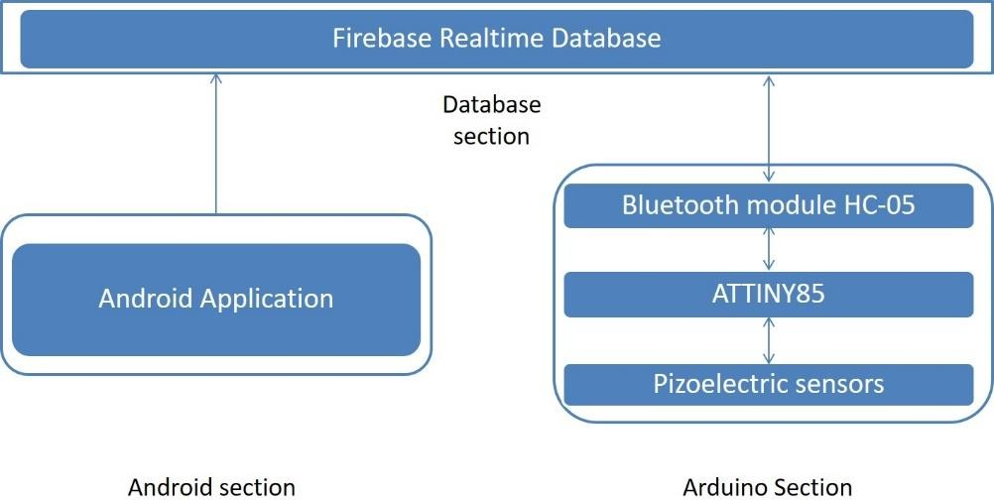

Figure 1. The architecture of the proposed helmet system

Java classes are connected to XML layouts to show the tracking system correctly. The first class is Helmet activity, and the second class is GPS Activity. By utilizing the java classes Phon Activity which is connected to activity_phone_auth.xml, the application user has to set his family (biker) mobile number in the first field in his app, followed by his/her mobile number in the second field, as shown. The tracking system enables the capability of performing phone number authentication. Authority to open location and GPS. During the time of the accident the app will send the exact location of the 15 secs alarm will not be disabled this seems that the rider is in danger. Adding family is a function in the proposed app which utilized to list persons who have permission to track the rider’s location instantly without needing permission that the rider is in danger the application will contain following lists:

* Authentication to riders’ phone contact list.
* Authentication to make a CALL via Bluetooth.
* Authentication to send SMS.

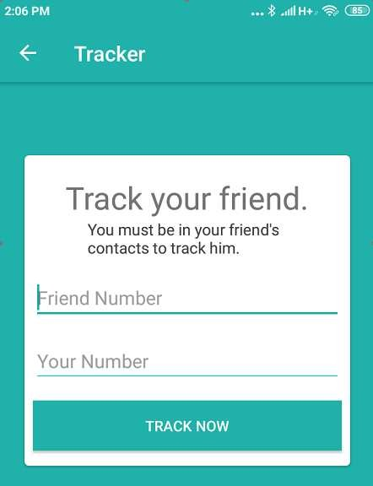

Figure 2. Android interface for the tracking

A progress bar will appear on the lower part of the screen as soon as the client press on the Track Now switch. During the progress bar filling the processes of checking and authenticating client phone numbers with the biker contact list were performed. Once the client’s phone number is in the biker contact list, the progress bar will be replaced with the word ‘Match’, to emphasize checking/authentication process is done. Therefore, the client and biker’s phone numbers are identical on both sides.

After performing the checking/authentication, the client can track the biker’s location by opening the new window named Maps Activity. Java, the biker’s current location appears in the window as a red marker. Algorithm 1 shows the algorithm stages at the Phone Auth Activity class, and Algorithm 2 shows how the application acquires data from the Database algorithm:

Algorithm 1. Phone Auth Activity class algorithm

***If the*** *track now button is pressed then the rider’s input and convert it into string and check the numbers to see if they are already in the Firebase.*

* 1. ***else***
  2. *print ‘your family member is not a rider’*
  3. ***endif***
  4. ***if the*** *user presses the arrow on the toolbar go back to the previous activity*
  5. ***else***
  6. *do nothing*
  7. ***endif***
  8. ***if*** *the rider’s friend number is empty print a toast ‘Please write your family number’*
  9. ***else if the*** *user number is empty*
  10. *print ‘Please write your number’*
  11. ***else***
  12. *perform checking*
  13. *make the loading bar visible*
  14. ***endif***

Algorithm 2. Calling data from the database algorithm

1. ***while*** *rider’s data! =null do:*
2. *Get data screenshot ‘rider’ node*
3. *Get the data as a condition to collect data*
4. *Set Array List to store all numbers*
5. *Set iteration through each user, ignoring their UID*
6. *Get the user map*
7. *Get the phone field and add it to the list*
8. ***end while***
9. ***while*** *‘rider _phone_ number’ !=null do:*
10. *checking*
11. ***end while***
12. ***if*** *the input Family member or ‘rider Ph’ was found in Firebase*
13. *Get all relative’s numbers and rider id*
14. ***end if***
15. ***if*** *input ‘your friend’ or ‘tracker’ = relative(no)*
16. *Go to maps activity*
17. *Send the rider’s id*
18. *Start tracking*
19. *Hide the loading bar*
20. *Go to GPs Activity by intent and send the rider’s id*
21. ***end if***
22. ***if*** *end search = disabled*
23. *stop checking*
24. ***endif***

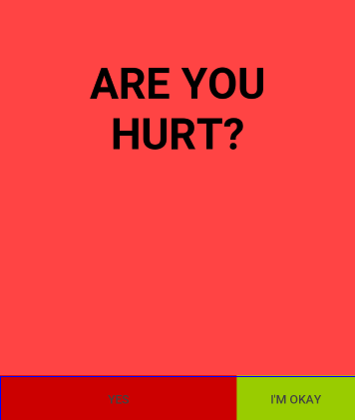

Figure 3. Questions appear when the helmet is a high knock

The helmet is connected to the APP through IOT and all the information about the helmet is saved inside the app which will give the details to our parents during the time of the accident. Suppose the rider fell from the bike an alert option will be shown on the app that are you hurt! If the message will not be declined within 15 sec then an Emergency alert will be sent to our contact list and to the nearest hospital.

Algorithm 3. The alert algorithm

***if*** *the rider’s helmet sends an “alert”*

* 1. *Running the alert and shows ask ‘Are you hurt’, the button ‘Yes’ and button ‘I am okay’*
  2. ***end if***
  3. ***if the*** *button ‘yes’ is pressed*
  4. *cancel notification() method and running alarm option showing alert() method, this method send message*

*"HELP ME! I JUST MADE AN ACCIDENT \n MY LAST LOCATION: "*

*to three friend numbers and call with number emergency*

* 1. ***else if the*** *button ‘I am okay’ is pressed*
  2. *cancel timer() method, shows emergency text “alert mode stopped by user “and finishes the alert*
  3. ***else***
  4. *timer() method begins and after 30 seconds running alarm option showing an alert) method*

9 ***end if***

At the hardware section the needed component:

− Arduino Board for monitor the piezoelectric sensors .

− Sensor utilized for highly accident intensity.

− Connection method between the android application and the helmet.

− Suitable Helmet to fit all the components into the helmet which will make it a 'smart helmet' .

− Suitable power supply (ex: battery cell) to start up the proposed system also weight of the battery will be under the given criteria so that it will not give a pressure to the skull.

− Compatible charging Board will be set so that battery will be charged when required.

The ATtiny85 represent the microcontroller utilized in this smart helmet due to its size and sufficient Competencies for the system. The USB Development Board ATtiny-85. Board will receive signals from knock Sensor (i.e., Piezoelectric Sensor) then send these reading to Arduino application via Bluetooth module (HC-05) for accident detection purpose. Also, the size of components considered, to integrate the Smart-Helmet. .

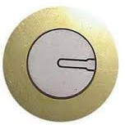

Figure 4 : piezoelectric sensor

Figure. 4 presents the Piezoelectric Sensor (also known as knock Sensor) which is utilized to measure changes in force, strain, temperature, or pressure by transforming them into an electrical charge. 3 piezoelectric sensors connected at three analog pins in ATtiny-85. The piezoelectric sensor includes two wires, the red wire represents the higher voltage which is linked to analog pin 0 and the black wire represents the lower voltage which is linked to the ground. Additionally, a 1-megohm resistor is linked in parallel connection with the Piezoelectric sensor to limit the current and voltage resulting from the piezoelectric and to shield the analog input. Figure 6 presents the Bluetooth Module HC-05. The HC-05 with full-duplex communication, which is used in many apps, It is used to send piezo reads to android applications.

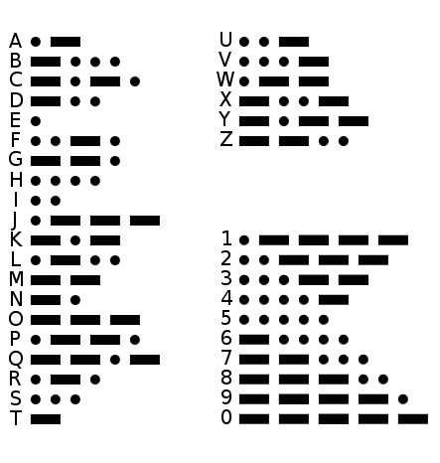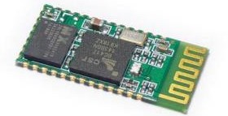

Figure 5. Morse code Figure 6. Bluetooth module HC-05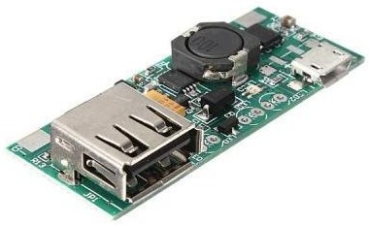

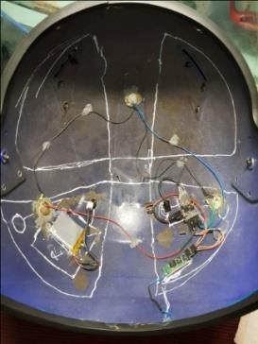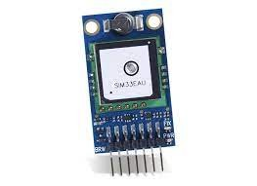

Figure 7. Battery charger module Figure 8 GPS

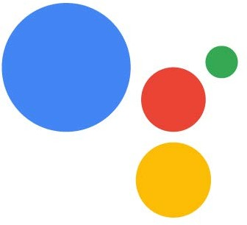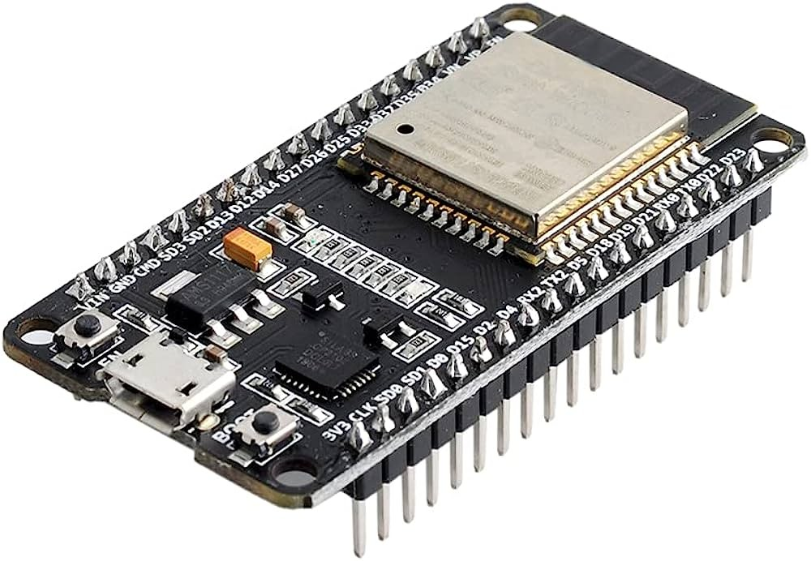

Figure 9. google assistant Figure 10. esp32

# RESULTS AND DISCUSSION:

# After a series of connections between piezoelectric sensors of mega ohm register of each, Then integrate each sensor with Bluetooth, battery, GPS, google assistant, and Morse code in the back. The smart helmet will cost around RS.3999 which is very cheaper in comparison with another helmet, Basically, we’re providing all safety features in this range which is quite affordable. we ‘re connecting our smart with the application after signing in to select the proper operation if the user needs to track the helmet owner. Application pressed or no action occurred within the next 15 seconds. An automatic message is sent to the police station and hospital in addition to the rider’s relatives with the help of this application rider’s life can be saved.

# With the help of only Rs 3999 a person’s life can be saved from death which is user-friendly and easy to use.

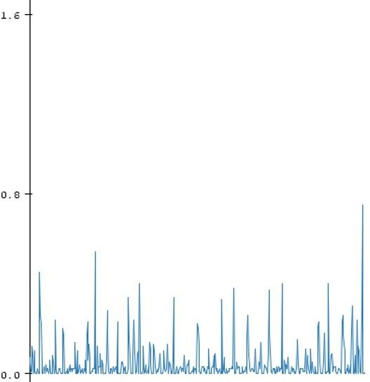

Figure 11. Piezoelectric signal voltage measurement :

# CONCLUSION :

Basically, the main feature of the helmet is to detect accidents and send an alert to emergency contacts with the help of SOS. These helmets are equipped with various sensors that can detect accidents and indicate accident-prone areas, They will send coordinates to the relatives or the nearest hospital which can save Riders life.

# REFERENCES :

# K..V Khattak, J. Shabir, A. W. Malik, and S. R. Muhammad, “A comprehensive study on IoT based accident detection systems for smart vehicles,” in IEEE Access, 122480-122497, 2023.

# A.Kamilaris, l..Iannarilli, V-m. Trifa and A.khatun, “Bridging the mobile web and the web of things in urban-bit microcontroller ATtiny-85,” 3rd International Tropical Renewable Energy Conference.

# S. U. Sharma and D. J. Shah, “A practical helmet detection and collision avoidance system using computer vision and IOT.